**Demonstrate how to parameterize requests**

Step-1:

First open postman

Step-2:

Then click on new button

Step-3:

Then click on HTTP

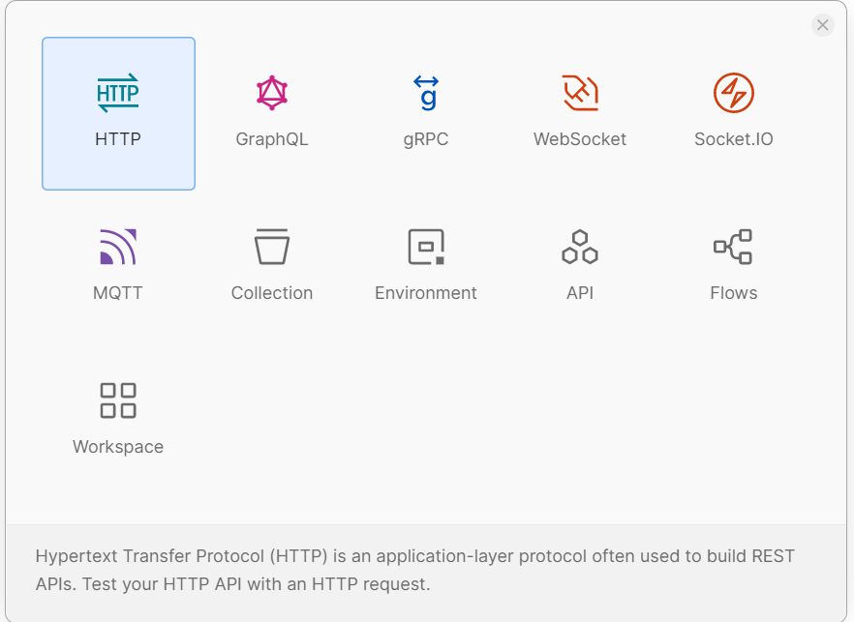

Step-4:

Then I enter a request url with query param

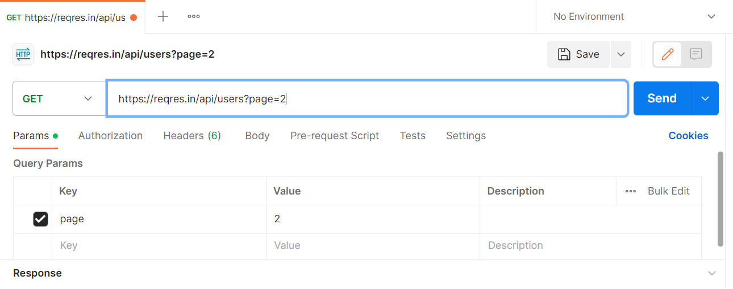

Step-5:

Then I click on send button

